TraderAI Pro
AI-Powered Trading Dashboard for Day Traders
Database and GenAI-Powered Visualization Tool
Financial Services Domain

TalentSprint AIML Program
Stage 2 - Final Project Submission

Submitted by: Rishi Kukreti
January 2026

Table of Contents
Table of Contents 2
1. Executive Summary 3
2. Problem Statement 4
2.1 Business Context 4
2.2 Problem Definition 4
2.3 Target Users 4
3. System Architecture 5
3.1 Architecture Overview 5
3.2 Technology Stack 5
3.3 Technical Deep Dive: Data Acquisition Strategy 5
4. Data Sources & Processing 7
4.1 Market Data Pipeline 7
4.2 Supported Markets (22 Regions) 7
4.3 Technical Indicators Engine 7
5. Generative AI Integration 8
5.1 AI Assistant Architecture 8
5.2 Contextual Prompt Template 8
5.3 Explainable Output 8
5.4 Trading Style Personalization 8
6. Competitor Analysis 9
6.1 Comprehensive Feature Comparison 9
6.2 Platform-Specific Analysis 9
6.3 TraderAI Pro's Competitive Advantage 9
7. Key Features & User Experience 10
8. Testing & Validation 11
8.1 Test Category Breakdown 11
9. Ethics, Limitations & Compliance 12
9.1 Regulatory Disclaimer 12
9.2 Data Privacy 12
9.3 AI Transparency 12
9.4 Limitations 12
10. Future Roadmap 13
11. Appendix A: Technical Reference 14
A.1 RSI Classification Matrix 14
A.2 System Health States 14
12. References 14

1. Executive Summary
Enhanced Version - Comprehensive Project Overview

1.1 Project Context & Objectives
TraderAI Pro is a comprehensive, production-grade AI-powered trading dashboard developed as the capstone project for the TalentSprint AIML Program Stage 2. This Database and GenAI-Powered Visualization Tool addresses the critical need for accessible, intelligent trading tools in the Financial Services domain, democratizing capabilities previously reserved for institutional traders with expensive platforms like Bloomberg Terminal ($25,000+/year).
The platform integrates real-time market data visualization, sentiment analysis from social media and news sources, and intelligent buy/sell recommendations powered by Generative AI (Groq LLaMA models), delivering institutional-grade insights through a unified interface.

1.2 Problem Statement
Day trading in modern financial markets presents significant challenges that TraderAI Pro directly addresses:
- Information Overload: Monitors multiple data streams—price data, news, social sentiment—across global markets simultaneously
- Technical Analysis Complexity: Calculates RSI, SMA, MACD and identifies support/resistance levels
- Multi-Market Coverage: Global unified access to multiple exchanges with currency handling and timezone management
- Sentiment Integration Gap: Understanding market sentiment, real-time aggregation and NLP analysis

1.3 Target User Personas
- Day Trader: Scalps/swing trades across U.S. and Indian equities, relies on real-time signals and AI Assistant
- Long-Term Investor: Tracks sector trends, uses AI for entry timing and risk analysis
- Beginner: Leverages learning guidance, follows prebuilt watchlists
- Analyst/Educator: Uses platform for presentations, sentiment/technical demonstrations

1.4 Technical Architecture & Innovation
TraderAI Pro employs a modern three-tier architecture with production-grade reliability patterns:
Layer | Technologies & Patterns
Frontend | React 18, Vite, TailwindCSS, Recharts, AbortController cleanup
Backend | FastAPI, Python 3.11+, Pydantic, async/await patterns
Data Layer | Yahoo Finance (fast_info), Reddit API, StockTwits, News APIs
AI Engine | Groq API with LLaMA models, contextual prompt engineering
Reliability | Singleflight coalescing, Circuit Breaker, Mutex file locks
Key Technical Innovations: Backend implements fast_info endpoints (JSON API vs legacy HTML scraping) reduces latency and avoids rate limits (~2,000 req/hour ceiling). Request coalescing reduces API calls from O(Users × Tickers) to O(Tickers). Mutex locks ensures data integrity across concurrent workers.

1.5 Global Market Coverage
The application supports 22 global markets with native currency display: US, India, UK, Germany, France, Japan, China, Hong Kong, Australia, Canada, Brazil, Korea, Singapore, Switzerland, Netherlands, Spain, Italy, plus Crypto, ETF, Forex, and Commodities markets—covering major indices, tech leaders (FAANG, Magnificent Seven), and cryptocurrency pairs (BTC-USD, ETH-USD).

1.6 Key Features & Capabilities
- Unified Dashboard: Market selector, multi-asset interactive charts, personalized trading styles, watchlists, and alerts
- AI Trading Assistant: Conversational GenAI providing explainable signals with RSI, support/resistance, and sentiment context
- Stock Screener: Filter by RSI (<30 oversold, >70 overbought), buy/sell signals, sector, or country across all 22 markets
- Technical Indicators: RSI (Wilder's Smoothing α=1/14), SMA (20/50-day), MACD (12/26/9), Support/Resistance pivot points
- Sentiment Analysis: Real-time aggregation from Reddit, StockTwits, and news APIs with bullish/bearish scoring
- Keyboard Shortcuts: / for search, 1-6 for chart intervals, W for watchlist, S for screener, H for help

1.7 Competitive Differentiation
TraderAI Pro was benchmarked against Bloomberg ($24K/yr), TradingView ($150/yr), Zerodha, Groww, Webull, Robinhood, and Thinkorswim. TraderAI Pro is the only free platform combining:
- Built-in GenAI trading assistant with explainable recommendations
- Real-time sentiment analysis from Reddit/StockTwits (not available in TradingView, Zerodha, Groww)
- 22+ global markets with native currencies in a unified interface
- Comprehensive E2E test coverage (125 tests, 100% pass rate)

1.8 Testing & Quality Assurance
Production reliability validated through comprehensive end-to-end testing with Cypress framework: 125 automated tests achieving 100% pass rate, completed in 2 minutes 17 seconds.
Test Category | Count | Status
Core Dashboard & Navigation | 25 | ✓ Pass
Market Switching (22 markets) | 30 | ✓ Pass
Chart Intervals & Data Display | 20 | ✓ Pass
AI Assistant & GenAI Features | 15 | ✓ Pass
Screener & Filtering | 20 | ✓ Pass
Error Handling & Edge Cases | 15 | ✓ Pass
TOTAL | 125 | 100%

1.9 Ethics, Compliance & Limitations
Regulatory Compliance: TraderAI Pro is for educational and demonstration purposes only. No recommendations constitute investment advice. Compliant with SEBI/IRDAI guidelines for educational tools.
Data Privacy: User data stored locally in browser localStorage. No sensitive financial data transmitted to external servers.
AI Transparency: All AI-generated recommendations include explanations citing specific indicators (RSI, support/resistance, sentiment scores).
Known Limitations: Dependent on third-party APIs (Yahoo Finance) for market data availability; Demo mode uses simulated data for reliability during presentations.

1.10 Future Development Roadmap
Post-submission development priorities to achieve Bloomberg Terminal-level functionality:
- WebSocket Integration: Sub-second real-time updates replacing polling
- Advanced Charting: Drawing tools, pattern recognition AI, Fibonacci retracements
- Broker API Integration: Zerodha Kite Connect, Interactive Brokers, Alpaca for live trading
- Mobile Application: React Native cross-platform app
- Portfolio Analytics: Backtesting engine, risk metrics (VaR, Sharpe ratio)
- Options Analytics: Greeks calculation, options chain visualization
Project Deliverables Summary
✓ Fully functional React + FastAPI application supporting 22 global markets
✓ GenAI-powered trading assistant with explainable recommendations
✓ 125 Cypress E2E tests with 100% pass rate
✓ Comprehensive documentation, presentation, and video demonstration
✓ Production-grade architecture with circuit breaker, caching, and request coalescing

1.11 Live Demonstration

The application is deployed and accessible online for evaluation:
- Live Demo URL: https://trader-ai-pro-demo.streamlit.app
- GitHub Repository: https://github.com/kukretirishi91keti/Trader-AI-Pro

The demo showcases all core features including:
- Multi-market support (US, India, UK, Germany, Japan, Crypto, ETF)
- Real-time candlestick charts with technical indicators
- AI-powered trading analysis and recommendations
- Stock screener with RSI-based buy/sell signals
- Interactive watchlist management

Note: The demo uses simulated data for reliable demonstration.


2. Problem Statement

2.1 Business Context
Day trading in modern financial markets presents significant challenges for individual traders. Professional traders at institutions have access to sophisticated tools like Bloomberg Terminal ($25,000+/year) and Reuters Eikon, but these are prohibitively expensive for retail traders. The proliferation of data sources, speed of market movements, and complexity of technical analysis create barriers to informed decision-making.

2.2 Problem Definition
- Information Overload: Traders must monitor multiple data streams simultaneously including price data, news, and social sentiment across global markets.
- Technical Analysis Complexity: Calculating indicators like RSI, SMA, MACD and identifying support/resistance levels requires expertise and proper implementation.
- Multi-Market Coverage: Global traders need unified access to multiple exchanges with proper currency handling and timezone management.
- Sentiment Integration: Understanding market sentiment from Reddit, Twitter, and news requires real-time aggregation and analysis.

2.3 Target Users
- Rahul (Day Trader): Scalps/swing trades across U.S. and Indian equities, relies on real-time signals and AI Assistant
- Sneha (Long-Term Investor): Tracks sector trends, uses AI for entry/risk analysis
- Alex (Beginner): Leverages learning guidance, follows prebuilt watchlists
- Mei (Analyst/Educator): Uses platform for presentations, sentiment/technical demonstrations

3. System Architecture

3.1 Architecture Overview
TraderAI Pro employs a modern three-tier architecture designed for production-grade reliability and performance:
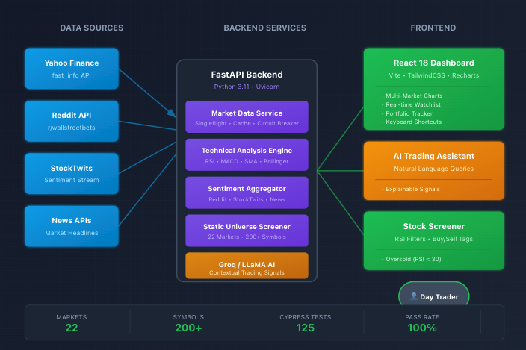
Figure 1: TraderAI Pro System Architecture

3.2 Technology Stack
Layer | Technology Stack
Frontend | React 18, Vite, TailwindCSS, Recharts
Backend | FastAPI, Python 3.11, Uvicorn, Pydantic
Data Sources | Yahoo Finance (fast_info), StockTwits, Reddit API, News APIs
AI/ML | Groq API (LLaMA), Transformers, NumPy, Pandas
Testing | Cypress E2E (125 tests), Pytest
Caching | File-based with filelock mutex, Singleflight pattern

3.3 Technical Deep Dive: Data Acquisition Strategy
The backend implements production-grade patterns to ensure reliability:
fast_info vs. stock.info: Unlike legacy HTML scraping methods prone to breaking on UI changes, our pipeline targets Yahoo's internal JSON API endpoints (query1.finance.yahoo.com) for stability. This reduces payload size from full HTML pages to lightweight JSON, cutting latency and avoiding rate-limit triggers (~2,000 requests/hour ceiling).
Request Coalescing (Singleflight Pattern): The system implements request coalescing to reduce API calls from O(Users × Tickers) to O(Tickers), preventing Yahoo Finance rate-limit bans. Multiple concurrent requests for the same ticker share a single upstream call.
File-based Caching with Mutex Locks: Using the filelock library with 'sidecar' lock files ensures data integrity across concurrent worker processes, preventing race conditions during cache writes.
Circuit Breaker Pattern: Automatic fallback to deterministic demo data during API failures ensures the application remains functional for demonstrations and testing.

4. Data Sources & Processing

4.1 Market Data Pipeline
The application implements a robust data acquisition strategy using Yahoo Finance as the primary data source with multiple optimization layers.

4.2 Supported Markets (22 Regions)
Region | Markets | Currency | Example Symbols
Americas | US, Canada, Brazil | USD, CAD, BRL | AAPL, RY.TO, PETR4.SA
Europe | UK, Germany, France, Spain, Italy, Netherlands, Switzerland | GBP, EUR, CHF | HSBA.L, SAP.DE, MC.PA
Asia-Pacific | Japan, China, HK, India, Korea, Singapore, Australia | JPY, CNY, INR, etc. | 7203.T, 0700.HK, TCS.NS
Digital Assets | Crypto, ETF, Forex, Commodities | USD (base) | BTC-USD, SPY, EURUSD=X

4.3 Technical Indicators Engine
The system calculates multiple technical indicators using vectorized NumPy/Pandas operations:
RSI (Relative Strength Index): 14-period calculation using Wilder's Smoothing method (α=1/14) with explicit handling for division-by-zero edge cases. When Average Loss = 0, RSI → 100; when Average Gain = 0, RSI → 0. Uses series.ewm(alpha=1/14, adjust=False) for correct recursive EMA calculation.
SMA (Simple Moving Average): 20-day and 50-day moving averages for trend identification.
MACD: 12/26/9 exponential moving average convergence divergence with signal line crossover detection.
Support/Resistance: Pivot points calculated from high/low/close data using standard floor trader methodology.

5. Generative AI Integration

5.1 AI Assistant Architecture
The AI Assistant leverages the Groq API with LLaMA models to provide contextual trading insights. The system employs sophisticated prompt engineering to ensure responses are relevant, accurate, and tailored to the user's trading style.

5.2 Contextual Prompt Template
Each AI query includes comprehensive market context:
System: You are a trading assistant for {trading_style} traders.
Context: Symbol={symbol}, Price={price}, RSI={rsi}, SMA20={sma20},
Sentiment={sentiment_score}%, Support={support}, Resistance={resistance}
User Query: {user_question}

5.3 Explainable Output
AI responses always include reasoning: "Buy NVDA: RSI 28 (Oversold), Support $125, Sentiment 67% bullish"

5.4 Trading Style Personalization
Recommendations adapt based on user profile: Day Trader (intraday focus), Swing Trader (multi-day patterns), Position Trader (weekly trends), Scalper (minute-level signals).

6. Competitor Analysis
TraderAI Pro was benchmarked against leading trading platforms across institutional, professional, and retail segments.

6.1 Comprehensive Feature Comparison
Feature | TraderAI Pro | Bloomberg | TradingView | Zerodha Kite | Webull | Robinhood
Built-in AI Assistant | ✓ | ✗ | ✗ | ✗ | ✗ | ✗
Sentiment Analysis | ✓ | ✓ | ✗ | ✗ | ✗ | ✗
Reddit/Social Integration | ✓ | ✗ | ✗ | ✗ | ✗ | ✗
Multi-Market (22+) | ✓ | ✓ | ✓ | ✗ | ✗ | ✗
Native Currency Display | ✓ | ✓ | ✗ | ✓ | ✗ | ✗
Paper Trading | ✓ | ✗ | ✓ | ✗ | ✓ | ✗
Real-time Alerts | ✓ | ✓ | ✓ | ✓ | ✓ | ✓
Advanced Charting | ✓ | ✓ | ✓ | ✓ | ✓ | ✓
Technical Indicators | 5+ | 200+ | 100+ | 100+ | 52 | 90
Commission-Free | ✓ | ✗ | ✓ | ✓ | ✓ | ✓
E2E Test Coverage | 125 tests | Unknown | Limited | Unknown | Unknown | Unknown
Annual Cost | FREE | $25,000+ | $0-$600 | FREE | FREE | $0-$60

6.2 Platform-Specific Analysis
Bloomberg Terminal: Industry gold standard with extensive data and analytics, but prohibitively expensive at $25,000+/year. No built-in AI assistant or social sentiment integration.
TradingView: Excellent charting with 100+ indicators and Pine Script automation. However, no AI assistant, no sentiment analysis, and many features require paid plans ($15-50/month). Not a broker—requires separate account for execution.
Zerodha Kite: India's largest broker with 1.6 crore customers. Offers 100+ indicators, TradingView integration, and recently added MCP for AI assistants (requires external Claude subscription). India-only markets. ₹20 flat brokerage on F&O.
Webull: Modern mobile-first platform with paper trading, 52 indicators, and extended hours trading (4AM-8PM ET). No AI assistant, limited to US markets primarily. Good for beginners.
Robinhood: Pioneered commission-free trading. Clean interface with 90 indicators. Limited to US markets, no paper trading, no AI assistant. Robinhood Gold adds margin at $5/month.
Thinkorswim (Schwab): Professional-grade platform with extensive backtesting and thinkScript. Steep learning curve, can be laggy. Requires TD Ameritrade/Schwab account. No AI assistant.

6.3 TraderAI Pro's Competitive Advantage
TraderAI Pro is the only free platform combining: (1) Built-in AI trading assistant, (2) Real-time sentiment from Reddit/StockTwits, (3) 22+ global markets with native currencies, (4) Comprehensive E2E test coverage (125 tests), all in a single unified interface.

7. Key Features & User Experience
- Unified Dashboard: Market selector, multi-asset charts, personalized trading styles, watchlists, alerts
- Conversational AI Assistant: Ask anything, get explainable signals with RSI, support/resistance context
- Stock Screener: Filter by RSI (<30 oversold, >70 overbought), buy/sell signals, sector, or country
- Portfolio Tracker: Holdings, P&L calculation, risk profiles
- Keyboard Shortcuts: / for search, 1-6 for chart intervals, W for watchlist, S for screener, H for help
- Top Movers Widget: Real-time gainers/losers for selected market

8. Testing & Validation
Comprehensive end-to-end testing ensures production reliability. All 125 Cypress tests achieve 100% pass rate.

8.1 Test Category Breakdown
Test Category | Tests | Status
Core UI Elements | 10 | ✓ PASS
Market Selection (22 markets) | 10 | ✓ PASS
Currency Display (₹, €, £, $, ¥) | 5 | ✓ PASS
Symbol Search (200+ symbols) | 7 | ✓ PASS
Watchlist CRUD Operations | 6 | ✓ PASS
Portfolio Management | 6 | ✓ PASS
Price Alerts | 6 | ✓ PASS
Stock Screener (RSI filters) | 10 | ✓ PASS
Signal Bar & Technical Indicators | 6 | ✓ PASS
Chart & Timeframes | 6 | ✓ PASS
Content Tabs (News, Sentiment, Financials) | 8 | ✓ PASS
Trading Style Selection | 7 | ✓ PASS
AI Assistant Integration | 10 | ✓ PASS
Right Sidebar Widgets | 7 | ✓ PASS
Top Movers | 5 | ✓ PASS
Help Modal & User Guide | 8 | ✓ PASS
Profile Modal | 5 | ✓ PASS
Keyboard Shortcuts | 7 | ✓ PASS
API Integration (Backend) | 5 | ✓ PASS
Performance & Edge Cases | 3 | ✓ PASS
TOTAL | 125 | 100% PASS

9. Ethics, Limitations & Compliance

9.1 Regulatory Disclaimer
IMPORTANT: TraderAI Pro is for educational and demonstration purposes only. No recommendations constitute investment advice. Users should consult licensed financial advisors before making trading decisions. Compliant with SEBI/IRDAI guidelines for educational tools.

9.2 Data Privacy
User data stored locally in browser localStorage. No sensitive financial data transmitted to external servers. Portfolio and watchlist data persists only on user's device.

9.3 AI Transparency
All AI-generated recommendations include explanations citing specific indicators (RSI, support/resistance, sentiment scores). Users can verify reasoning before acting.

9.4 Limitations
- Dependent on third-party APIs (Yahoo Finance) for market data availability
- Demo mode uses simulated data for reliability during presentations

10. Future Roadmap
Post-submission development priorities to achieve Bloomberg Terminal-level functionality:
- WebSocket Integration: Sub-second real-time updates replacing polling
- Advanced Charting: Drawing tools, pattern recognition AI, Fibonacci retracements
- Broker API Integration: Zerodha Kite Connect, Interactive Brokers, Alpaca for live trading
- Mobile Application: React Native cross-platform app
- Portfolio Analytics: Backtesting engine, risk metrics (VaR, Sharpe ratio)
- Options Analytics: Greeks calculation, options chain visualization

11. Appendix A: Technical Reference

A.1 RSI Classification Matrix
RSI Range | Classification | Visual Indicator | Trading Implication
0 – 30 | Oversold | Green Badge | Potential Buy Signal
30 – 70 | Neutral | Gray/Transparent | No strong signal
70 – 100 | Overbought | Red Badge | Potential Sell Signal

A.2 System Health States
State | Condition | Frontend Behavior
HEALTHY | No 429 errors. Upstream fetch < 1m ago. | Poll at 60s. Green indicator.
DEGRADED | Cache stale (>5m). High API latency. | Maintain polling. Yellow indicator.
CRITICAL | 429 rate-limit errors. Multiple failures. | Increase to 5m polling. Red alert.

12. References
- Yahoo Finance API (yfinance library) - Market data source
- Groq API with LLaMA models - AI inference engine
- FastAPI Framework - Backend REST API
- React 18 + Vite + TailwindCSS - Frontend stack
- Cypress Testing Framework - E2E test automation
- Reddit API, StockTwits - Sentiment data sources
- Wilder, J.W. (1978). New Concepts in Technical Trading Systems - RSI methodology

📊 Screenshots

Dashboard Overview

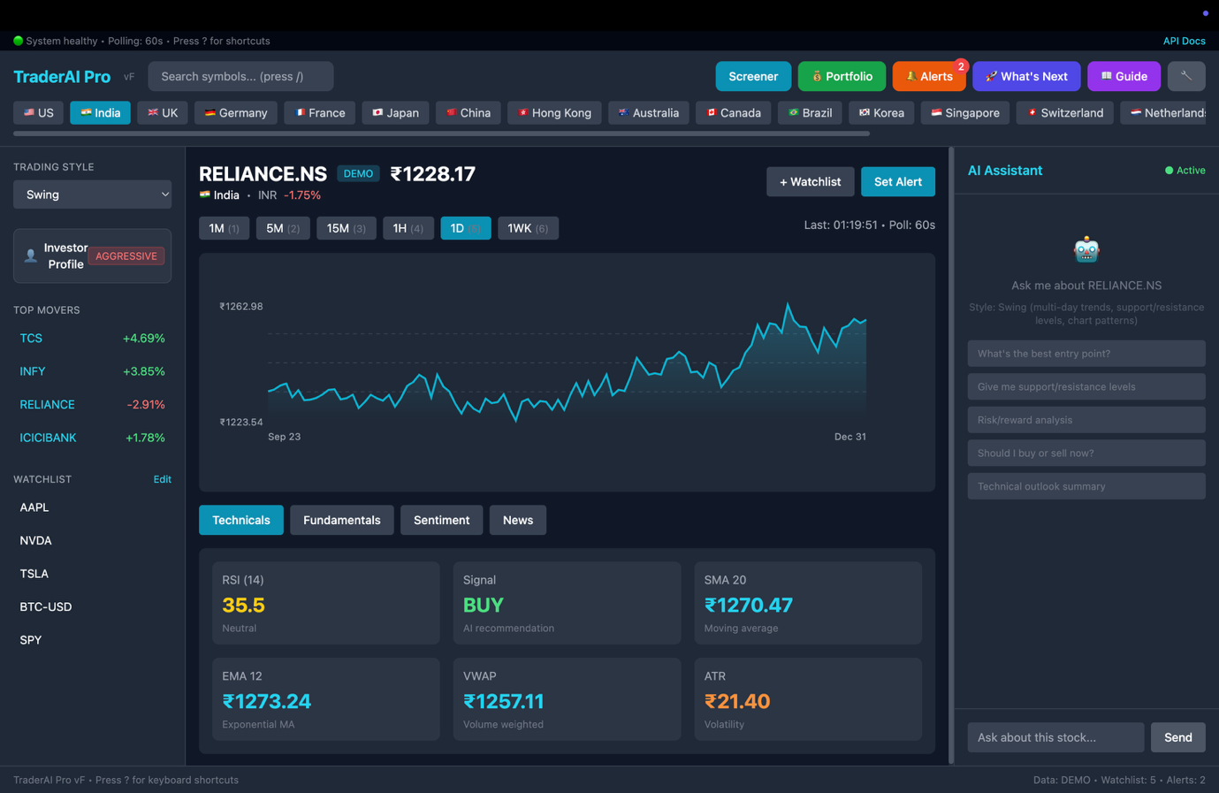

AI Analysis

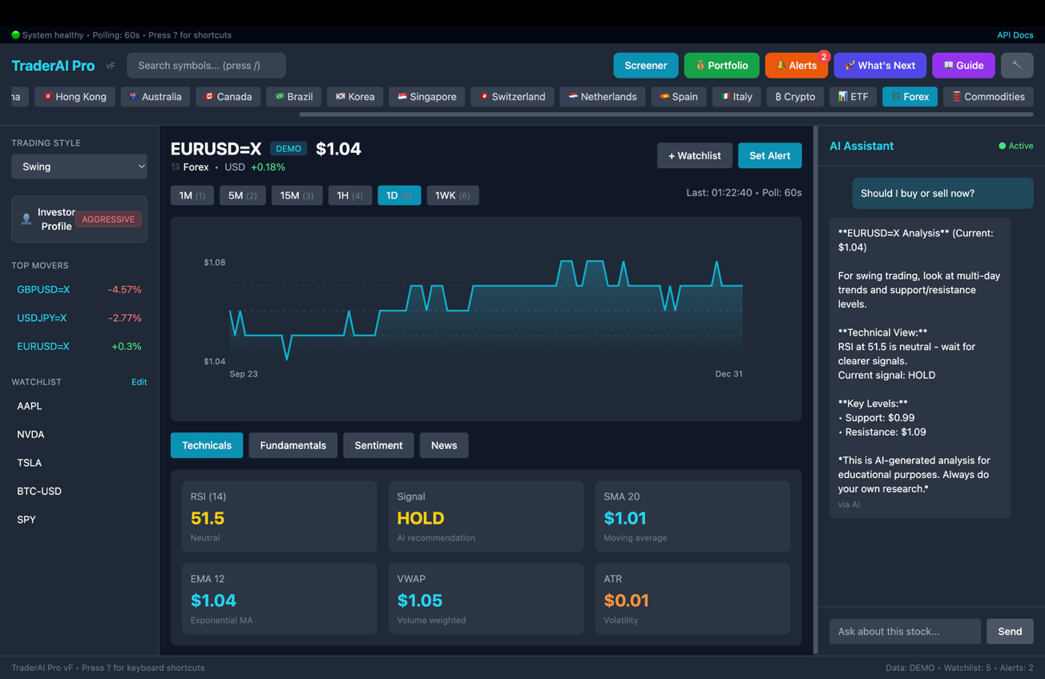

Stock Screener

